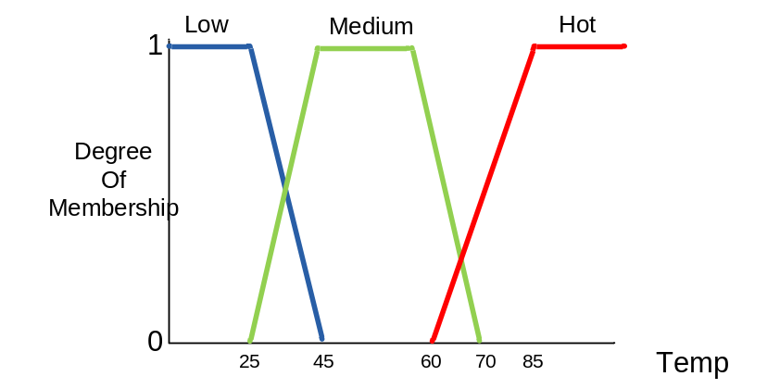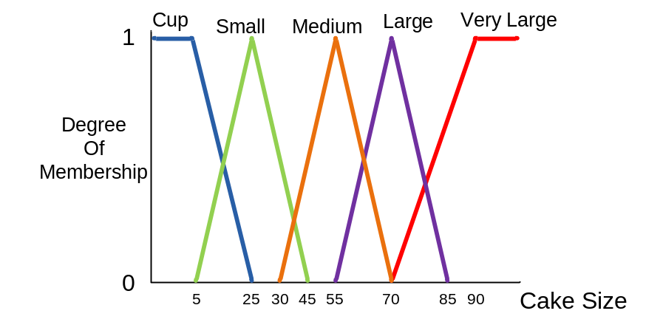

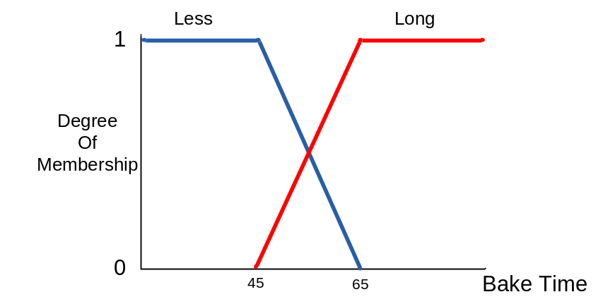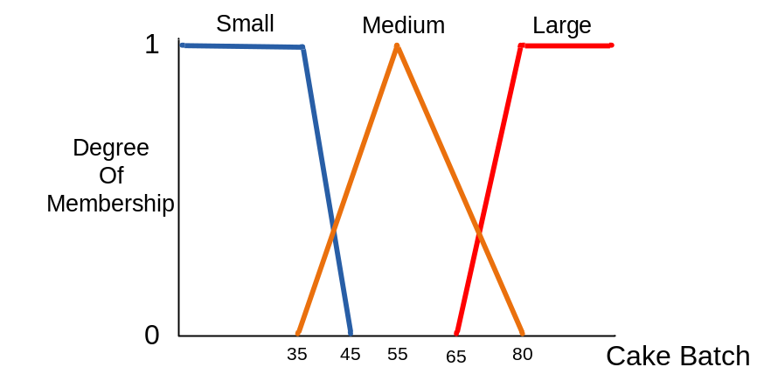

Figure 1: Membership function

IF Cup Cake Size AND Low Temp AND Large Batch THEN Long Time
IF Cup Cake Size AND Hot Temp AND Large Batch THEN Less Time
IF Large Cake Size AND Low Temp AND Large Batch THEN Long Time
IF Small Cake Size AND Low Temp AND Small Batch THEN Less Time
Figure 2: Control rules

Figure 1 shows the membership function of fuzzy image processing systems and Figure 2 shows the system control rules. Using jFuzzyLogic tool and program the problems.
- Find the time to bake the cake with 20 cm cake size, 40 degree temp, and 75 cakes batch.

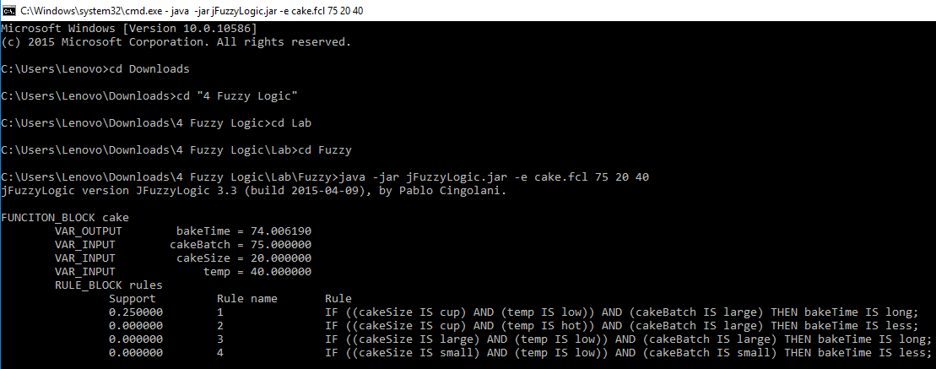

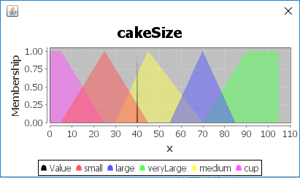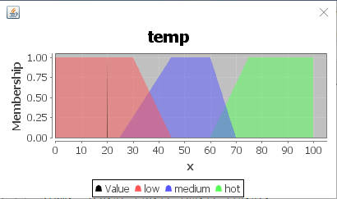

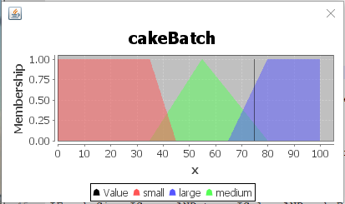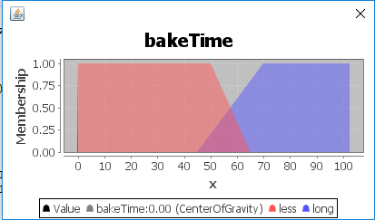
FUNCTION_BLOCK cake

VAR_INPUT
cakeSize : REAL;
cakeBatch : REAL;
temp : REAL;
END_VAR

VAR_OUTPUT
bakeTime : REAL;
END_VAR

FUZZIFY cakeSize
TERM cup:= (0,1) (5,1) (25,0);
TERM small:= (5,0) (25,1) (45,0);
TERM medium:= (30,0) (45,1) (70,0);
TERM large:= (55,0) (70,1) (85,0);
TERM veryLarge:= (70,0) (90,1) (105,1);
END_FUZZIFY

FUZZIFY cakeBatch
TERM small:= (0,1) (35,1) (45,0);
TERM medium:= (35,0) (55,1) (80,0);
TERM large:= (65,0) (80,1) (100,1);
END_FUZZIFY

FUZZIFY temp
TERM low:= (0,1) (30,1) (45,0);
TERM medium:= (25,0) (45,1) (60,1) (70,0);
TERM hot:= (60,0) (75,1) (100,1);
END_FUZZIFY

DEFUZZIFY bakeTime
TERM less:= (0,1) (50,1) (65,0);
TERM long := (45,0) (70,1) (100,1);
METHOD : COG;
DEFAULT := 0;
END_DEFUZZIFY

RULEBLOCK rules
AND : MIN;
ACT : MIN;
ACCU : MAX;

RULE 1 :IF cakeSize IS cup AND temp IS low AND cakeBatch IS large THEN bakeTime IS long;
RULE 2 :IF cakeSize IS cup AND temp IS hot AND cakeBatch IS large THEN bakeTime IS less;
RULE 3 :IF cakeSize IS large AND temp IS low AND cakeBatch IS large THEN bakeTime IS long;
RULE 4 :IF cakeSize IS small AND temp IS low AND cakeBatch IS small THEN bakeTime IS less;
END_RULEBLOCK

END_FUNCTION_BLOCK

